About this Easy Read

 | This is an Easy Read version of Social Work Scotland’s draft standards for Self-Directed Support.
 | Self-directed support is sometimes called SDS.
 | Social Work Scotland is there to help to make sure that social workers have all the training and information they need to do their jobs the best they can.
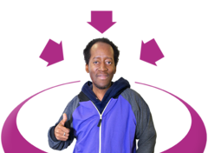 | Social work Scotland thinks that Self-directed support can be better for the people that get it.
 | Social Work Scotland has made a list of things that they think will help to make sure Self-directed support works better for people.
 | These are called Standards.
 | Social Work Scotland want to hear from you about what you think about these standards.
 | These standards should be used by local councils and Health and Social Care Partnerships.
 | The standards should be used with any one who is applying for or already has a budget.

About Self- Directed Support

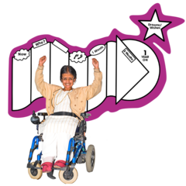 | Self-directed Support is the name given to a way of organising the support you get.
 | It is supposed to make sure you get a choice about what you do with your support, where you get support and who gives you support.

About the standards
 | Social Work Scotland want to know what people think about the standards.
 | In this easy read you will read the standard the way it is written by Social Work Scotland.
 | Then there will be an Easy Read explanation of that standard.
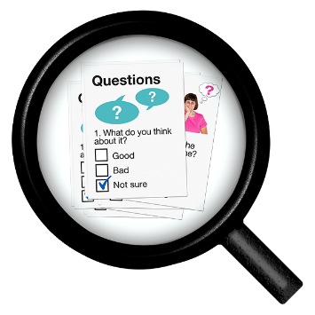 | Then you will have some space to say what you think about the standard.
 | There are 11 standards.

Standard 1
Adults, children, young people and their carers are offered independent advice, support and advocacy to have choice and control over their social care and support and to exercise their human rights.
What this means

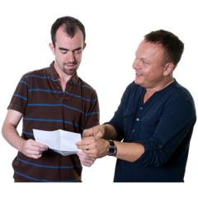 | Anyone who wants Self-directed support should be told about people who can help them to get it.
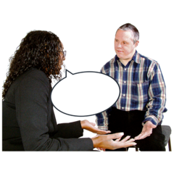 | The help might be information and advice to help you understand.
 | The help might be support to go through the application.
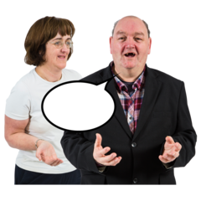 | The help might be advocacy support to help you to say what you want,
 | These should be from someone who is not involved in making the decisions about your budget or support.
 | This support and advice should help to make sure that you get to make choices about the support that you get.
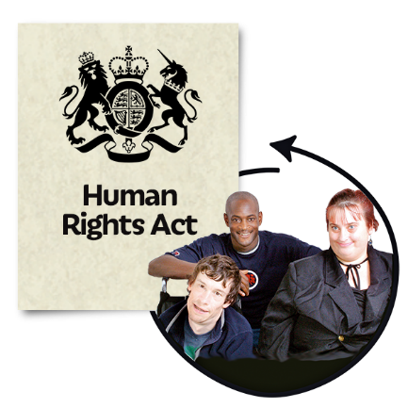 | This support should help to make sure that you are given your human rights.

What do you think?
Do you think that making sure everyone gets given extra support when they are applying for Self-directed support is a good idea?

Please also say why you think that.
Please write your answer here
Is there anything else you would like to say about this standard? Please write it here

Standard 2
Early help and support is available to all people who need it.
What this means
Everyone who needs support or advice to apply for Self-Directed Support should get it.

This support should be given to them as soon as possible.

What do you think?
Do you think that making sure support is given as early as possible is a good idea?

Please also tell us why
Please write your answer here
Is there anything else you would like to say about this standard? Please write it here

Standard 3
Assessment, support planning and review systems and processes are personalised, recognising people’s strengths, assets and community supports, and result in agreed personal outcomes.
What this means
 | The support you get should be what you want.
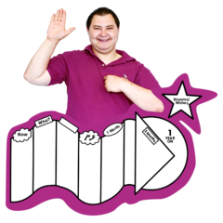 | Each person should be able to plan their own support.
 | Reviews of support should be individual and based on the person’s own goals.
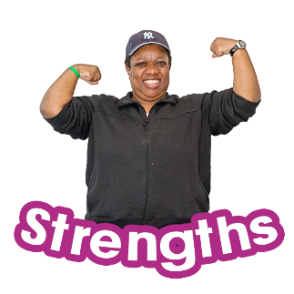 | Support should be based on a person’s own strengths and abilities.
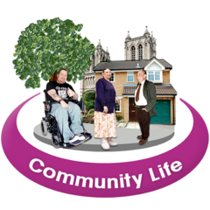 | Support plans should include support people have from their family and community.
 | The person should set their own life goals and their support should be planned to help them get that.

What do you think?
Do you think support should be based on the wants and needs of each individual person?

Please also tell us why?
Please write your answer here
Is there anything else you would like to say about this standard? Please write it here

Standard 4
Agreed personal outcomes are monitored through ongoing review processes. Reliable outcome data is captured routinely, is used for continuous improvement, and demonstrates the extent to which SDS practice is carried out as intended.
What this means
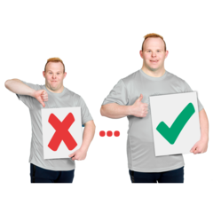 | We will check how well your support plan is helping you to reach your goals.
 | What we find out will help us to support you better.
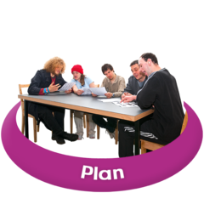 | Your own plan might be changed to make it work better.
 | The information will also be used to make sure that Self-directed support is working in the best way.

What do you think?
Do you think it is a good idea to regularly keep track of how well your plan is working for you?

Do you think using information from your reviews should help to make Self-Directed support better in the future?

Please also tell us why?
Please write your answers here
Is there anything else you would like to say about this standard? Please write it here

Standard 5
Clear and supportive processes are in place for SDS decisions to be challenged and appealed.
What this means
 | If you are not happy about decisions that have been made about your budget or your support plan you can ask for it to be changed.
 | You will always receive support when doing this.
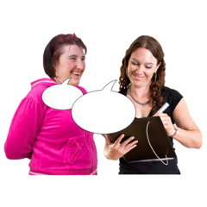 | It will be easy to ask for these changes.
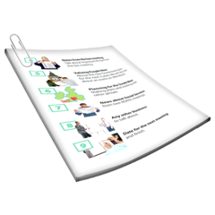 | There will be clear information to say how you make a complaint.

What do you think?
Do you think being supported to complain if you are not happy about decisions is a good idea?

Please also tell us why?
Please write your answer here
Is there anything else you would like to say about this standard? Please write it here

Standard 6
Workers and supported people work together through shared decision making to plan for positive risk enablement whilst balancing the responsibility of statutory protection of children, young people, adults, and carers. Consideration should be given to supported decision making in relation to capacity.
What this means
Supported decision making will be used when deciding your support plans.
Supported decision making is when people you trust such as family, friends or carers help you to make decisions.
Councils, Health Boards and Health and Social Care partnerships have to keep you safe.
Sometimes they think too much about keeping people safe and do not let them try new things.
They should allow you to try things and to take some risks.
This will be done while making sure that you are safe.

What do you think?
Do you think people should be supported to make decisions?

Do you think people should be allowed to take risks?

Please tells us why
Please write your answers here
Is there anything else you would like to say about this standard? Please write it here

Standard 7
Commissioners shape the local markets to support people to live their lives in ways which evidence choice and control over their care and supports.
What this means
Commissioners are people who are in charge of planning and managing care and support in a local council.
Commissioners make decisions about which support organisations are allowed to work in the council area.
Commissioners should make sure they give choice to people who have a budget.
This means that commissioners need to let people have choices about who they get support from.

What do you think?
Do you think that making sure commissioners give people more choice and control is a good idea?

Please tell us why
Please write your answer here
Is there anything else you would like to say about this standard? Please write it here

Standard 8
Workers are enabled to exercise professional autonomy in support planning and setting personal budgets within agreed delegated parameters.
What this means
 | Decisions about budgets need to be approved by a manager in the social work department.
 | Your own social worker should be allowed to make more decisions themselves.
 | This would make it quicker for people to get a decision on their budget.
 | The people who support you should be allowed to make some decisions with you about your support.
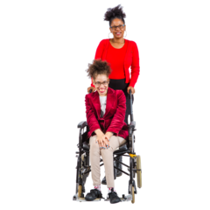 | This would mean that support could be more flexible.

What do you think?
Do you think that allowing you and your support staff to make more decisions about your support is a good idea?

Do you think allowing your social worker to make decisions about budgets is a good idea?

Please tell us why?
Please write your answers here
Is there anything else you would like to say about this standard? Please write it here

Standard 9
Processes and decisions that affect a supported person’s social care budget and options are recorded and/or explained in ways that make sense to the supported person. This includes helping the person understand what direct care and support they are eligible for, their level of contribution and how a budget can be spent.
What this means
The agreements that are made about your budget or support plan will be written down.
Your budget and support plan will be explained to you in a way which you can understand.
You will be given information about your options in a way you can understand.
You will be told how much money you will have to pay towards your support in a way that you can understand.

What do you think?
Do you think giving people clear information about their budget and support plan is a good idea?

Please also tell us why
Please write your answer here
Is there anything else you would like to say about this standard? Please write it here

Standard 10
The Principles of Good Transitions are embedded within SDS policy, planning and practice across all sectors as a framework to support young people and families. Transition planning processes have the person’s wellbeing, aspirations and personal outcomes at the centre. Young people and their families are given the time, information and help they need to make choices and have control of their care and support as they move into the next phase of their lives.
What this means
 | The Principles of Good Transitions is a plan to help young people with learning disabilities or autism when they are moving on from school into whatever they want to do next.
You can see more about The Principles of Good Transition by going to this webpage.
https://scottishtransitions.org.uk/7-principles-of-good-transitions/

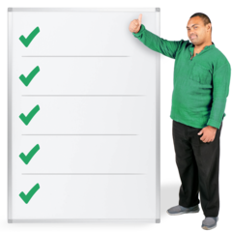 | These principles are used in Self-directed support to help you to have control of your adult life.
 | Using these principles makes sure that your hopes for your life will always be thought about when planning your support.
 | If you are a young person you and your family will be helped with choices that affect you as you move to adult life.

What do you think?
Do you think helping young people to have control of their care as they become an adult is a good idea?

Please tell us why.
Please write your answer here
Is there anything else you would like to say about this standard? Please write it here

Standard 11
Supported people moving from one local authority to another can expect their agreed personal outcomes to be met in a comparable way.
What this means

If you move to a different local council you will receive the same support as you did before you moved.

Your life goals and plans will stay the same if you move to a different local council area.

What do you think?
Do you think keeping your support the same if you move into a new council area is a good idea?

Please also tell us why
Please write your answer here
Is there anything else you would like to say about this standard? Please write it here

