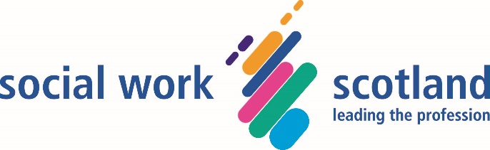

Reducing the backlog of Unpaid Work hours: Coronavirus (Scotland) Act 2020

Social Work Scotland Position Paper
15 July 2020

Introduction

- Social Work Scotland is the professional body for social work leaders. Over recent months we have been monitoring closely the evolving situation within the criminal justice system, with a particular concern over the management of unpaid work and other court mandated activities. We are taking this opportunity to set out our position regarding the community order ‘variation’ provisions contained within Schedule 4, Part 6 (Section 15) of the Coronavirus (Scotland) Act 2020 (hereafter referred to as ‘the Act’), which we believe must now be used to reduce the backlog in unpaid work hours. The extension of community orders with unpaid work requirements has bought the justice system valuable time, but without a systematic reduction in the number of outstanding unpaid work hours (through revocation or variation of orders) there is a major risk that Justice Social Work (JSW) will be overwhelmed, with serious consequences for the wider justice system.

Background

- Most, if not all, local authorities suspended unpaid work programmes following the lockdown implemented in Scotland on 23 March 2020. When the Act came into force, two measures were introduced to “allow justice social work to suspend all programmes relating to unpaid work or other activity requirements for the duration of the pandemic without affecting the ability of individuals to complete their hours within court-directed timescales”. These were:

- the time limit for the completion of all existing unpaid work or other activity requirements in community payback orders (CPOs) were extended by 12 months; and
- restrictions were placed on courts to ensure that any new unpaid work or other activity requirements have a time limit of at least 12 months from the point of imposition.

- While these provisions were welcome, when paired with the resumption of court business (and new community orders) they have effectively only delayed a crisis. Physical distancing requirements will reduce justice social work’s capacity to deliver unpaid work for the foreseeable future. Placements will be rationed, and individuals will attend their placement less frequently. As the length of time to complete orders is increased it will affect motivation, which, in our professional experience, results in more people breaching their orders. Unpaid work has a very high profile with the judiciary and the public. If decisive action is not taken to reset the system within deliverable parameters, community justice policy as a whole could be undermined, impeding the Scottish Government in its efforts to reduce custodial sentences, such as the extension of the Presumption Against Short Term Sentences (PASS) to 12 months in 2019.

Current position

- The Scottish Government’s letter to Chief Social Work Officers of 18 June explained how Scotland’s journey through the Route Map would apply in the justice system, stating “With pandemic restrictions beginning to be gradually relaxed, we recommend that the delivery of unpaid work or other requirements be restarted, on a limited basis, over the next few weeks.” Local authorities are now actively planning for the restarting of unpaid work or other activity, taking account of physical distancing and stringent health & safety measures to be compliant with Scottish Government and local government guidance.

- However, the scale of the challenge is significant. Data collected from all local authorities in mid- to late-May 2020 showed that approximately 700,000 hours of unpaid or other activity were outstanding across Scotland. Further information obtained in June 2020 showed that only 6 local authorities were in a position to deliver unpaid work or other activity at that time. And in these areas work was on a very small scale (e.g. one supervisor working with one individual in an outdoor placement, or work being completed at home, e.g. making crafts at home or bird boxes which can be assembled and then sold or donated) or related to ‘other activity’ (e.g. sessions on alcohol and drugs being delivered by phone).

- Traditionally, the unpaid work element of a requirement is delivered by JSW. Most unpaid work is delivered by a supervisor managing a group of up to 5 individuals carrying out a range of indoor and outdoor projects, for example grass cutting, painting & decorating, landscaping, etc. Individuals are also placed with agencies in individual placements managed by that agency (e.g. a charity shop) and complete other activity, for example completing educational work, or work relating to their offending, including referral to the Third Sector.

- The challenges of resuming these kind of unpaid work activities in the context of COVID-19 are clearly set out in Social Work Scotland’s Justice Social Work Route Map. That document provides principles and guidance across the range of JSW business, assisting local planning as we move through the four Phases of the Scottish Government’s route map for Scotland. But as the Scottish Government has itself made clear, the transition through the Scottish Government’s route map may not be smooth making planning and preparation for the resumption of certain activities very difficult. For example, it will be some time before a ratio of 1 supervisor to 5 individuals can be achieved, given the range of factors to be taken into account, including:

Physical Distancing
- Transport of individuals to and from unpaid work. Public transport has been restricted and the current 2 metre rule means that alternative methods of transportation will be required as most unpaid work vehicles will not accommodate this. This may require hiring other types of vehicles or asking more individuals to travel under their own steam to the work site.
- The 2 metre rule may be relaxed, for example to 1 metre, but equally a second wave may lead to further lockdowns locally or nationally and an increase in the rule.
- Waiting areas will be restricted which will also impact where individuals are reporting to offices before unpaid work or for induction.
Type of projects
- These will require in the main to be either outdoors or in large and well-ventilated indoor spaces. The impact of inclement weather and the autumn and winter will undoubtedly affect capacity as it always does.
- Work undertaken will require to be simple and straightforward without the need for delivering close instruction on how to operate tools or machinery.
Public facilities
- Public toilets, and those within supermarkets and other public places, have been closed during lockdown. Where they remain unavailable, alternatives will be required. This might mean shorter working days (normally 7 hours) or stopping work and transporting individuals to facilities.
Personal Protective Equipment
- After initial teething problems and limited availability, PPE required for COVID-19 has been available for JSW. There will be an increased demand for this as unpaid work restarts. To date the levels of demand are untested.
Individual placement providers
- Providers will be met by many of the same challenges as JSW. This will reduce capacity as providers restructure their own spaces to be COVID-19 compliant and to accommodate a reduction in their own on-site work force. Increasing the volume of individual placements takes time and will not be able to off-set the underlying capacity reduction.

- In resuming unpaid work a number of other factors also require to be considered. For Scotland’s test, trace and isolate system, for example, JSW will put contingencies in place across its range of business activity. But the impact (on processing the backlog of hours) of a member of staff, or someone on an order, testing positive and the consequent need for people to self-isolate for 14 days cannot be under-estimated. This could see whole teams sidelined.

The coming months

- The impact of the issues identified above can be mitigated to some extent, such as by hiring additional staff, paying overtime, hiring different vehicles, investing in portable toilets, moving to “muster points” near to the work venue rather than transport from a central location, seeking revocation from a court of individual unpaid work or other activity requirements where the majority of hours have been completed (or applying for an extension) and increasing the use of other activity in imaginative, new and different ways. Moreover, there may not be a second wave and Scotland may progress relatively smoothly to Phase 4. But increasing staffing is costly and recruitment typically takes around 4 months; and as these contracts would by necessity have to be short-term, this may impact on recruitment and the quality of appointments. Staff then require induction and training, further complicated in the current environment.

- Funding for the delivery and commissioning of justice social work services is provided under sections 27A and 27B of the Social Work (Scotland) Act 1968 and in 2020/21 includes additional funding to support community and non-custodial interventions. Confirmation that there is flexibility in relation to this specific funding to help support justice social work’s response to COVID-19 has been welcome, and will assist local authorities in considering whether they can afford to build capacity in the ways outlined above.

- It is not possible to be precise as to when each local authority will restart unpaid work. It is likely that the majority will do so by end-July, at least on the limited basis of a 1:1 ratio of supervisor to individual, with some other activity and very limited individual placements being provided. This approach takes into account all the factors outlined above, and is due to the need to ensure physical distancing and the health, safety and wellbeing of staff and individuals due to COVID-19. But the outcome is that, looking at Scotland as whole, more than a third of the 2020-21 year will have passed with no unpaid hours being worked, and the backlog increasing to unmanageable levels.

- The situation is exacerbated by the resumption of solemn and summary business in the court system. Whilst courts have been closed in April and May the number of new Community Payback Orders and Drug Treatment and Testing Orders (in Sheriff courts) have reduced to <5% of normal levels. There are now very significant numbers of trials and court cases waiting to be heard. Although it will be many months before courts are operating at normal volumes of business, new community orders will now be made. It is reasonable to assume that the total of new orders (albeit over a longer period of time) will be equivalent to those made had Coronavirus not happened. The number of new unpaid work or other activity requirements being made per quarter during 2020/21 will only increase slowly when compared to previous years, but critically the overall total number of new hours is likely to equate to or even exceed those mandated in 2019/20. To be blunt, given the existing backlog of order hours, we expect JSW to be asked to deliver on a substantially increased volume of work, within a reduced and less flexible capacity.

- As acknowledged above, restrictions were placed on courts to ensure that any new unpaid work or other activity requirements have a time limit of at least 12 months from the point of imposition for the duration of the Coronavirus (Scotland) Act 2020. This has been crucial, and we believe there is a strong argument to extend this further, beyond 30 September 2020. The volume of new orders will only start to increase from the autumn, and it would significantly contribute to building in further capacity to ensure they are completed timeously and to avoid a raft of CPO reviews impacting on court business.

Quantifying the scale of the challenge

- Data relating to current unpaid work requirements (at the end of May 2020) was collated from 28 of the 32 local authorities in Scotland. From this we estimate that:

- Authorities are currently responsible for the implementation of around 10,000 CPOs with an unpaid work or other activity requirement.
- Approximately half of these orders have unpaid work requirements and supervision and the remaining half with unpaid work alone.
- 37% of orders are Level One and 63% Level Two unpaid work requirements.
- There is an estimated 700,000 hours of unpaid work outstanding. This is around 76 hours per current unpaid work requirement which would take a minimum of 12 weeks for each person to complete at a rate of 7 hours per person each week.

- For the purposes of this paper, ‘resources available’ is defined as the total hours unpaid work supervisors have available from 1 July 2020 to 30 June 2021, with which they can supervise unpaid work requirements. The calculation is based on a 35-hour working week with appropriate reductions in hours for preparation time, annual leave, public holidays, training and sickness absence. These hours are then multiplied according to the ratio of supervisor to individuals on orders (i.e. 1:1, 1:2 etc.). The total sum of this calculation is the total hours of unpaid work that can be supervised at that ratio of worker to person subject to a requirement.

- In terms of COVID-19, for safety and whilst any form of physical distancing is required, the ratio is likely to range between 1:1 to 1:3 maximum for the foreseeable future. In Graph 1 below, resources available are compared to the outstanding unpaid work hours with the percentage difference demonstrating capacity within each local authority area based on different physical distancing requirements: 1:1, 1:2 and 1:3 as shown.

Graph 1 – Capacity
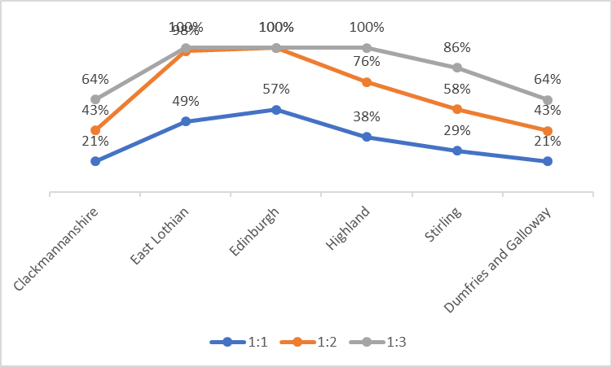

Sources – CPO Unit Return Data 18/19 & Scenario Planning Returns May 2020
- As the graph illustrates:

- 1:1 (blue) shows a significant reduction in capacity. All six authorities show capacity ranging from approximately 21% to 57%.
- 1:2 (orange) shows that five of the six authorities would continue to experience significant reductions in capacity. The exception is Edinburgh who have, proportionately, a significantly higher level of full-time equivalent supervisors compared to the other five authorities.
- 1:3 (grey) means half of authorities should be able to deliver the expected orders but half still couldn’t. It must be borne in mind that this is a snapshot of only six authorities and at present and given the variance, all that can clearly be stated is that some areas are likely to be able to function more effectively than others with reduced capacity.

- An additional consideration, in terms of resource capacity, is the number of placements simultaneously needed to deliver existing outstanding unpaid work requirements. Graph 2 shows the ratio of supervisor to individual should all individuals currently subject to an outstanding unpaid work requirement be placed in a work placement and where the individual is working one day per week over 7 days.

Graph 2 – Ratio of supervisor to individual
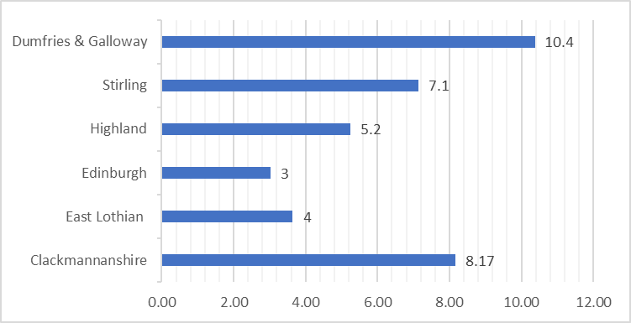
Sources – CPO Unit Return Data 18/19 & Scenario Planning Returns May 202 *Includes continuations for breach applications based on 40% rate

- As can be seen from Graph 2 above:

- Five of the six authorities cannot achieve the maximum anticipated ratio of 1:3. For example, one supervisor in Dumfries & Galloway would require to supervise more than 10 individuals at a time in order to implement all current outstanding unpaid work requirements.
- Four authorities exceed the maximum 1:5 ratio permitted. The results for Edinburgh are caused by the comparatively high breach rate (37%) of unpaid work requirements as well as the comparatively high numbers of supervisors compared to others.
- If all current outstanding unpaid work requirements cannot be placed timeously this will result in significant delay and a further backlog of the implementation of requirements over the 12-month period.
- The number of current outstanding orders with requirements of unpaid work, taken at the end of May 2020, excludes any estimation of new requirements made during the following twelve-month period.

- In summary, based on the resources currently available, it will not be possible to complete all current outstanding hours within the next 12 months. Moreover, new unpaid work requirements will continue to add to the problem. A second pandemic wave leading to further national or local lockdowns, an increase in physical distancing and any significant impact resulting from track, isolate and trace will further compound this. It is impossible to plot an exact trajectory, but on the basis of what we currently know, and the fragility of our path out of lockdown, further legislative action seems necessary if we are to keep community justice operating effectively.

- However, in anticipation of an argument that Scotland further extends the time period of completion for unpaid work or other activity requirements (as a way of mitigating the immediate burden), Social Work Scotland would not support this, because:

- It does not address the accumulating backlog of hours.
- It requires careful consideration about the length of time an order takes, the interests of justice and the impact on the person serving the order (as was acknowledged in the Coronavirus (Scotland) Act 2020)
- It will affect motivation and may be counterproductive, with an increasing risk of individuals failing which would, in fact, be against the spirit of the Act which states that any action taken must not make CPOs more onerous to complete.

- Notwithstanding the almost total cessation of unpaid work or other activity requirements, throughout the pandemic individuals subject to community payback orders (CPOs), Drug Treatment and Testing Orders (DTTOs) and prison licences have continued to be supervised. It remains important to continue to actively manage individuals in order to address offending related needs, contribute to community safety, public protection and keeping victims safe, and ensure those individuals that are vulnerable, such as those subject to DTTOs and CPOs with mental health, alcohol and drug requirements, for example, continue to receive the help and support they require during this unprecedented time. There are significant concerns about the rise in domestic abuse and the impact on victims and it is crucial JSW continues to contribute to addressing these fundamental concerns. The JSW workforce has remained resilient, with the absence rate of justice social workers varying between 4.2% (at 23/6/20) and 7.7% throughout the pandemic. For these reasons, Social Work Scotland does not see the need for, nor would support, any postponement, variance or revocation of community orders other than those requiring unpaid work or other activity.

Conclusion

- We believe the evidence presented above is unequivocal. Utilising a sample of six local authorities, it demonstrates that the majority of areas will be unable to deliver the accumulated backlog of unpaid work hours, let alone successfully manage the imposition of new orders. If the findings from these six local authorities are extrapolated for Scotland as a whole, we estimate that would equate to 450,000 hours going uncompleted, around two-thirds of our current backlog of hours (700,000). This means approximately 28% of unpaid work or other activity requirements would expire without being fully completed.

- Social Work Scotland has therefore concluded that, to ensure the safety of staff and individuals subject to orders, and to maintain the viability of the community justice system, legislative action is necessary to reduce the backlog of unpaid work hours, utilising the powers provided to Ministers under Schedule 4, Part 6 (Section 15) of the Coronavirus (Scotland) Act 2020. Taking no action to reduce the backlog invites the risk of system failure. Indeed we believe there are clear parallels here with the emergency early release of prisoners, where swift action was taken to ensure the Scottish Prison Service had the ability to sustain a viable service during COVID-19 and to protect front-line staff and prisoners. There is now an urgent necessity to similarly proactively address the pressures faced by local authority justice social work services in managing the unpaid work or other activity requirements of Community Payback Orders.

Proposal

- To address the issues and risks identified above, we recommend that Scottish Government use the powers provided in the Coronavirus (Scotland) Act 2020 to vary existing orders relating to unpaid work or other activity, reducing the total number of outstanding hours to be worked by 450,000. This level of reduction would minimise the chances of unpaid work or other requirements expiring without being completed.

- We recognise the importance of proportionality, equity and necessity in considering further use of the Coronavirus (Scotland) Act 2020. A reduction of unpaid work hours at this scale would be a significant move. We make our recommendation in full awareness of how serious such a step would be. But we believe that it is only through such a step that we can secure the medium term viability of our community justice system. Bold but proportionate action now will help safeguard the system into the future.

For further information please contact:

James Maybee
Chair, Social Work Scotland’s Justice Standing Committee

james.maybee@highland.gov.uk
admin@socialworkscotland.org

Coronavirus (Scotland) Act 2020 http://www.legislation.gov.uk/asp/2020/7/contents
Letter from Chief Social Work Adviser and Director, Justice Directorate to CSWOs 3/4/20
The Presumption Against Short Periods of Imprisonment (Scotland) Order 2019 http://www.legislation.gov.uk/sdsi/2019/9780111042175/contents
Letter from Chief Social Work Adviser and Director, Justice Directorate to CSWOs 18/6/20
Coronavirus (COVID-19): Scotland's route map through and out of the crisis, Scottish Government 21/5/20
Please note that, although individuals have mostly been unable to undertake unpaid work over recent months, it must be stressed that they remain subject to the court order, and JSW has maintained contact with them in-person (face-to-face), phone and/or letter, and we have continued to monitor progress. Many will be subject to supervision and other requirements and have continued to serve their orders and receive interventions.
“A group placement is one to which two or more individuals may be assigned and which is supervised by a member of the unpaid work team and/or an approved agency provider. Group placements should not normally contain more than 5 individuals at any one time” (p84 Community Payback Order Practice Guidance, Scottish Government January 2019).
Social Work Scotland’s Justice Social Work route map 29/6/20 https://socialworkscotland.org/publication/justice-social-work-routemap/
Unpaid work or other activity requirements can be imposed for between 20 and 300 hours; a Level 1 requirement specifies between 20 – 100 hours and a Level 2 between 101 – 300 hours. The key difference is that for a Level 1 requirement the individual does not require to have been convicted of an offence which is punishable by imprisonment (in contrast to Level 2).
Resources available are then compared to the total number of outstanding hours for current unpaid work requirements as at end May 2020 excluding breach applications, although hours have been included based on a 40% continuation rate for breach applications in line with the 2018/19 published CPO data. This assumes courts resuming business at one third of normal business from June 2020, an additional third of new requirements has been added for the first two quarters and Level one requirements added for quarter 3 and 1 month of quarter 4 as these would be expected to be completed during the 12-month period. An adjustment has been applied for non-attendance based on the average breach rate of 15%.
Wherever possible authorities will aim to offer more than one day per week; however, normal capacity only allows for one day per week.
https://www.gov.scot/publications/domestic-abuse-forms-violence-against-women-girls-vawg-during-covid-19-lockdown-period-30-3-20-22-05-20/pages/3/ Scottish Government 19/6/2020

