Providing Community Equipment to Prisons
  - A protocol for the Assessment, Delivery and Uplift of Community Equipment in Prisons

Contributors

Forth Valley Health & Social Care Partnerships (Falkirk and Clackmannanshire & Stirling)
Alison Docherty, Independent Advisor, Equipment, Housing, & Occupational Therapy, on behalf of iHub
Scottish National Association of Equipment Providers
Scottish Prison Service

Contents
Contributors 1
Key Principles 3
Introduction 3
Scale of the Issue 3
What is Community Equipment 4
Assessment 4
Health and Social Care Integration 5
Roles and Responsibilities 6
Documentation 7
Appendix A: Process for the Referral, Assessment, Provision and Recycling of Community Equipment to people in prison 8
Appendix B: Form E1, Equipment agreement for IA and SPS re suitability, safety and security of equipment. 11
Appendix C: Form E2, Confirmation equipment is fit for purpose 12
References 13

Providing Community Equipment to Prisons
  - A protocol for the Assessment, Delivery and Uplift of Community Equipment in Prisons

Key Principles
• • •
Equipment will be provided on the basis of eligible assessed need.
All assessments will be carried out either by appropriately trained HSCP staff for complex needs, or relevant prison based NHS healthcare staff for non-complex needs.
SPS will provide a range of standard equipment to meet long-term needs.
The HSCP will provide equipment to meet short-term, temporary needs.
Wherever possible, equipment should be procured, maintained, and paid for through local community equipment stores.
Access to, and use of, recycled equipment should be encouraged.
SPS and the HSCP should agree arrangements for the tracking, maintenance, decontamination and recycling of community equipment across the prison estate.

Introduction
The objective of this Protocol is to promote a consistent and reliable approach to the assessment, provision and uplift, of community equipment to people in custody in prisons across Scotland.
Numerous national and international statutes, including the UN declaration of human rights and the World Health Organisation, affirm the right of those in custody in prison to healthcare equivalent to that available to those not in custody in prison.
This guide provides an example of how the Scottish Prison Service (SPS) and Integration Authorities (Health & Social Care Partnerships) could work in partnership to assess need, and provide appropriate equipment to meet those needs. This guide is based on the principles of the Protocol for the Provision of Equipment to Care Homes and work carried out by the Forth Valley Health & Social Care Partnerships (Falkirk and Clackmannanshire & Stirling) to develop a joint protocol.

Scale of the Issue
The SPS 2015 Prisoner Survey 30% of respondents described themselves as having a long term condition while 26% described themselves as having a disability.
The Prison Reform Trust highlights that disability and mobility needs within the prison population are commonplace. It estimates that 36% of people in prison have a physical or mental disability, compared to 19% of the general population.
The Scottish Prison population is also growing older. As of 5th September 2017 of those SPS had in custody over 980 were aged over 50 (13%) and over 150 (2%) were aged over 65. Between 2010 and 2016 the number of men aged over 50 in the Scottish prison population rose by over 60% while the number of men in prison aged over 65 increased by 68% over the same period.

What is Community Equipment
The Guidance on Equipment and Adaptations describes community equipment as ‘Any item or product system, whether acquired commercially off the shelf, modified or customized that is used to increase the functional capabilities of individuals with disabilities. Community equipment can include, but is not limited to:
- Equipment for those who are more dependent, such as Moving & handling equipment, pressure relieving mattresses and hospital beds.
- ‘Daily living’ equipment, for example shower chairs and stools, bathlifts, raised toilet seats, commodes, rails, transfers aids, and seating.
- Mobility equipment such as walkers, walking frames and sticks.
- Telecare products including flood detectors, falls monitors, smoke detectors and motion sensors. These are often linked to a call centre and trigger a response when activated.
- Sensory equipment such as flashing doorbells and text phones
- Communication equipment, including Alternative and Augmentative Communication (AAC) devices to assist people who have difficulty with speech.
It does not include any medical devices or anything that is invasive to the body (e.g. PEG feeding equipment).”

Assessment
With appropriate training and support, the assessment of need, and provision of equipment can be carried out by a wide range of professionals, including prison based NHS healthcare staff. Partnerships should consider local need for the development of training and support to prisons in their locality.
A range of online tools are also available to support prison based NHS health care staff to work with people in prison to identify any need for equipment. See good practice example below.
Good Practice Example – Training prison based clinicians to assess for basic equipment

In Dec 2017 managers with responsibility for the Community equipment service within Perth & Kinross HSCP, met with the Head of Nursing for NHS Tayside Prisoner Healthcare. It was agreed that a number of nursing staff based in Perth prison will be given access to the Elms on-line ordering system, to allow them to directly access core stocks of daily living aids, pressure care, handling and moving equipment, and basic walking aids.
Training on assessing and use of the equipment is planned to be delivered in February 2018 and once each member of the prison nursing team have completed their training, they will register their details on Elms so accesses can be opened up for use. In particular it was identified that opening up access for basic walking aids would reduce the need for people in prison to attend hospital for a physio assessment.

In 2019, Equipu Community Equipment service trained prison based health care staff in Barlinnie prison to directly order equipment on the web-based ordering system. As above, this has allowed a more direct route to the provision of equipment and better knowledge of potential needs and solutions within the health care staff.

Health and Social Care Integration
The Public Bodies (Joint Working) (Scotland) Act 2014 established the legal framework for the integration of health and social care in Scotland. The Act requires each Health Board and Local Authority to delegate some of their statutory functions, and associated budgets, to their Integration Authority (Health & Social Care Partnership). The HSCP is then responsible for the planning and delivery of the related services.
Local Authorities, along with other relevant partners, need to consider how the delegation of functions can best be implemented for the benefit of all individuals assessed as requiring support. Where equipment and adaptations are provided, these services, along with the resources which fund this support must be included in the integration arrangements.
Each HSCP must prepare a Strategic Commissioning Plan which sets out how they will plan and deliver services, including community equipment, for their area over the medium term. Stakeholders must be fully engaged in the preparation, publication and review of the strategic commissioning plan, in order to establish a meaningful co-productive approach.
Good practice would suggest that partnerships with prisons within their locality should work with the SPS to assess the needs of their prison population, and agree appropriate arrangements for the provision, maintenance and review of community equipment provided to meet assessed needs.
Further guidance on the Integration of Health and Social Care is available at http://www.gov.scot/Topics/archive/Adult-Health-SocialCare-Integration/Implementation/ImplementationGuidance.

Roles and Responsibilities
HEALTH & SOCIAL CARE PARTNERSHIP (HSCP) | NHS Prison healthcare staff | SCOTTISH PRISON SERVICE (SPS) | COMMUNITY EQUIPMENT STORE (CES)
Work in partnership to agree a range of core stock suitable for use within the prison environment, taking into account the potential need for increased security, health and safety standards and other environmental factors.
Work in partnership to agree procurement and funding arrangements for all community equipment provided to people in prison.
Work in partnership to agree arrangements for the tracking, maintenance, decontamination and recycling of community equipment across the prison estate.
Work in partnership to provide training to prison based healthcare staff (e.g. prison nurses) on the assessment of basic needs, and provision of simple equipment to people in prison
Work in partnership to agree a list of relevant leads/contacts to support effective communication between agencies.
Undertake an assessment of people in prison with higher level/complex needs, and ensure any equipment proposed is “fit for purpose” - meeting the person’s needs while considering the environment. | Carry out assessment of people in prison with simple/low level/standard needs  Refer more complex cases to HSCP for assessment of needs. | Identify people in prison who may have a need for community equipment.
Following assessment will recommend appropriate equipment to meet the assessed need. | Following assessment will order the required equipment directly from the Store service | Confirm the equipment meets SPS safety/security standards and assess any implications of providing recommended equipment to individual (see above).
Fund equipment to meet short-term, temporary (3 months or less) needs, to aid recovery and rehabilitation. Recommend to SPS, equipment required to meet complex long-term needs |  | Fund equipment to meet the long-term needs of people in prison. | Process equipment orders and liaise with the relevant named prison contact to agree a time and named contact for delivery of the equipment.
 | Complete form E1 to confirm equipment will meet assessed needs (HSCP assessor) and that SPS security and safety standards have been considered (SPS named contact).
 | Co-ordinate the delivery, installation and demonstration (if necessary) of the equipment to the person, and any other relevant person who may use the equipment (e.g. guard, prison buddy).
Copy of Form E3 will be saved into relevant IA records/ | Form E3 will be completed and placed on person’s file.
Complete assessment once equipment is in situ to ensure needs are appropriately met.
Agree procedure/timescale for regular review and maintenance of equipment.
 |  | Liaise with the relevant named prison contact to confirm a mutually agreed uplift time and place for equipment, when no longer required.

See also appendix A for process flowchart.

Documentation
Form E3 (see Appendix 1) will be signed by the assessing HSCP professional to confirm that equipment is fit for purpose and then counter-signed by an SPS representative to confirm that any safety/security implications of the provision of the recommended equipment have been considered and that SPS standards are met.
SPS will retain Form E3 within in the person in prison’s file on the Prison Hall and a copy will be also placed within the person in prison’s NHS vision record? by the relevant health professional.
If there is a disagreement about the equipment recommended by the HSCP assessor this will be documented as above and escalated to senior management within the IA and SPS.

Appendix A: Process for the Referral, Assessment, Provision and Recycling of Community Equipment to people in prison
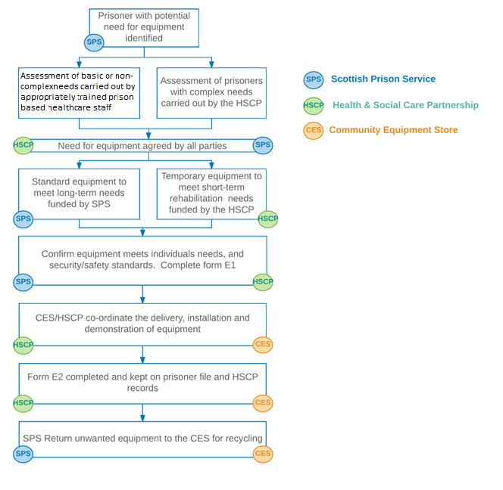

Appendix B: Form E1, Equipment agreement for IA and SPS re suitability, safety and security of equipment.
Name:

Spin: |  | CHI:
The person above has been assessed by a IA (HSCP) staff member as requiring the following item/s of equipment to meet their health & social care needs. The equipment is suitable for their functional ability and for the structural environment. The equipment has also been agreed by an SPS staff member as appropriate for the individual in terms of security and the prison environment.
Purpose of equipment  e.g. showering | Type of product  e.g. shower chair |  | Name of product
Health & Social Care Partnership |  | Scottish Prison Service
Name (Print) |  | Name (Print)
Signature |  | Signature
Date: |  | Date:

Appendix C: Form E2, Confirmation equipment is fit for purpose
Name:

Spin: |  | CHI:
The person above has been assessed by a HSCP staff member as requiring the following item/s of equipment for health/rehabilitation purposes. The equipment is suitable for their functional ability and for the structural environment. The equipment has also been agreed by an SPS staff member as appropriate for the individual in terms of security and the prison environment.

1

2

3

4

5

6

 | Health & Social Care Partnership |  | Scottish Prison Service
 | Name (Print) |  | Name (Print)
 | Signature |  | Signature
 | Date: |  | Date:

References

Where local, joint working arrangements fall within the spirit of this protocol we would not expect partnerships to change these arrangements, simply to fall in line with this guide.
Principle 9, The United Nations (1990) Basic Principles for the Treatment of Prisoners - http://www.ohchr.org/EN/ProfessionalInterest/Pages/BasicPrinciplesTreatmentOfPrisoners.aspx
The World Health Organisation: Prisons - http://www.who.int/topics/prisons/en/
Protocol for the Provision of Equipment to Care Homes, 2012 - http://www.gov.scot/Topics/Health/Support-Social-Care/Independent-Living/Equipment-Adaptations/Carehomes-Protocol
SPS Prisoner Survey 2015 http://www.sps.gov.uk/Corporate/Publications/Publication-4565.aspx
SPS Estatewide Social Care Needs Assessment 2017 http://www.sps.gov.uk/Corporate/Publications/Publication-4941.aspx
Scottish Government Guidance on the Provision of Equipment and Adaptations, 2009 - http://www.sehd.scot.nhs.uk/publications/CC2009_05.pdf
Public Bodies (Joint Working) (Scotland) Act 2014 -http://www.legislation.gov.uk/asp/2014/9/pdfs/asp_20140009_en.pdf
Health & Social Care Functions Supporting Note - http://www.gov.scot/resource/0046/00467396.pdf
Strategic Commissioning Plans Guidance - http://www.gov.scot/Topics/Health/Policy/Adult-Health-SocialCare-Integration/Implementation/ImplementationGuidance/SCPlans

