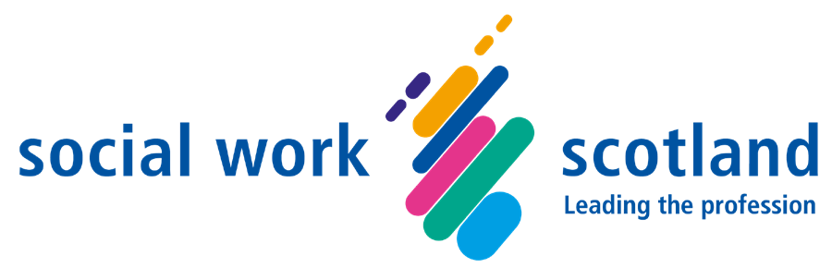

Self-directed Support Framework of Standards
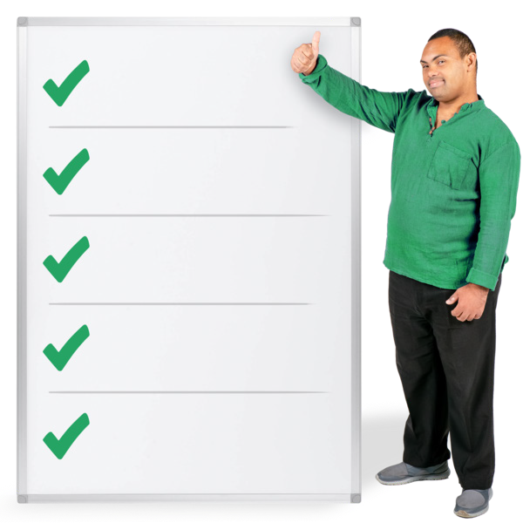
Easy Read
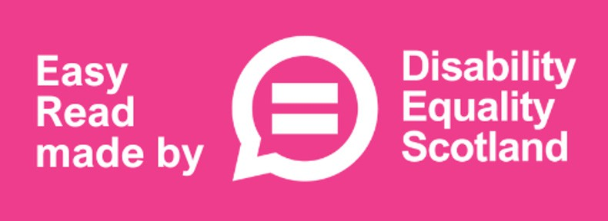



About this document

This is an Easy Read information document.

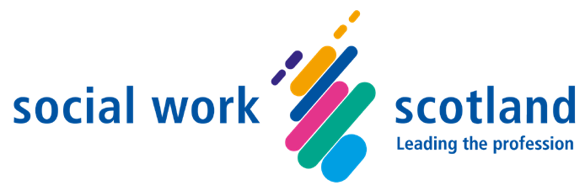
The information was written by Social Work Scotland with help from lots of people interested in Self-directed Support.

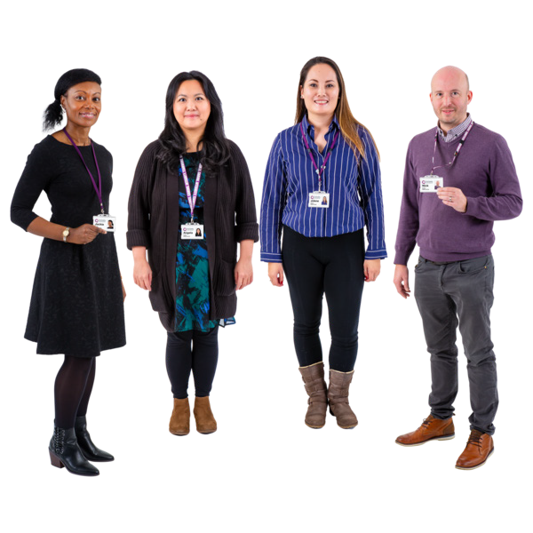
Social Work Scotland is an organisation which supports and leads:

- social work staff
- social work managers

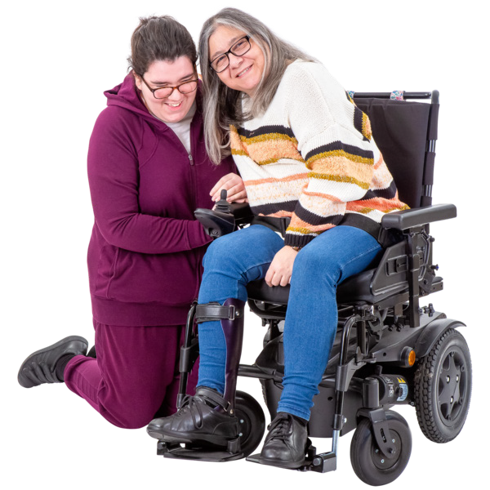
Social work means ways of supporting people to live full and happy lives and make their own decisions.

Social work also keeps people safe.


This document will tell you about how Self-directed Support should happen in Scotland.

About Self-directed Support


Self-directed Support is when people choose how their support is organised.

About the Framework of Standards

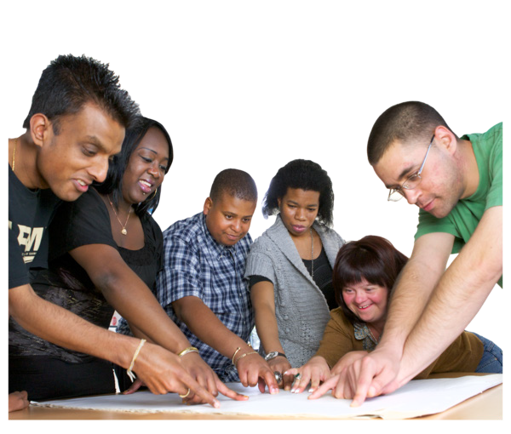
Social Work Scotland have written information about what good Self-directed Support looks like.


Our information is written in a plan called a Framework.

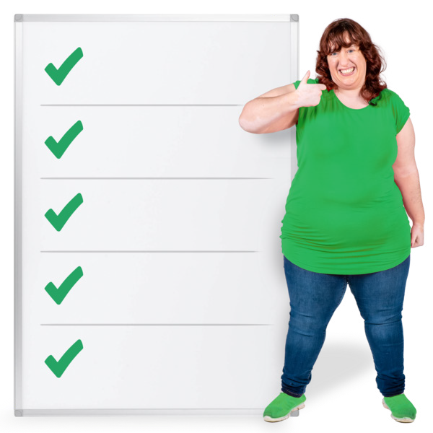
The Framework tells everyone what needs to happen and who needs to do it.

The 12 Standards

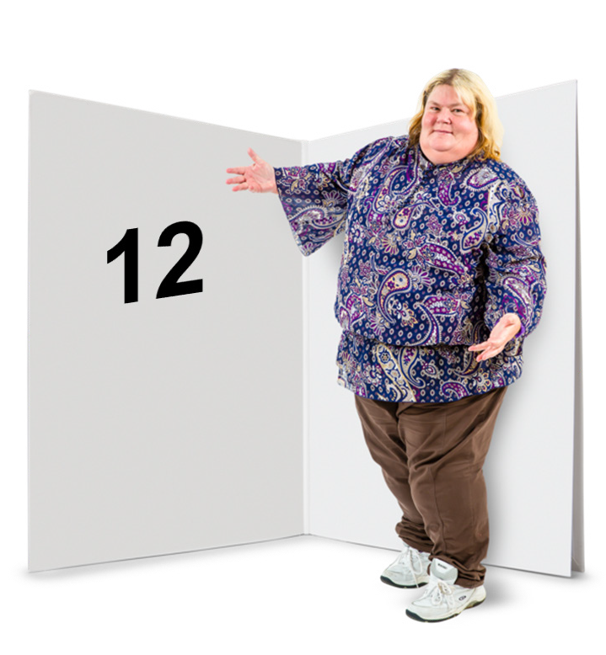
There are 12 important things that local councils will work on to make Self-directed Support better.

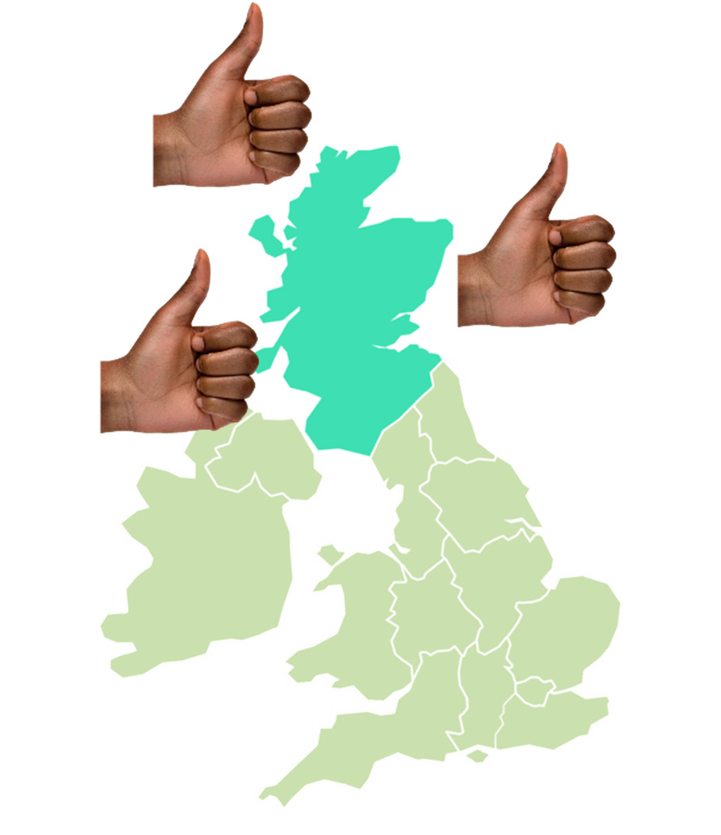
These are called the 12 Self-directed Support Standards.

In this document Standards mean that wherever in Scotland someone lives, they should be offered good support.


Each of the 12 Standards say:

- what people should get – this is called a

Standard Descriptor

- what staff and systems will do – this is called a Practice Statement

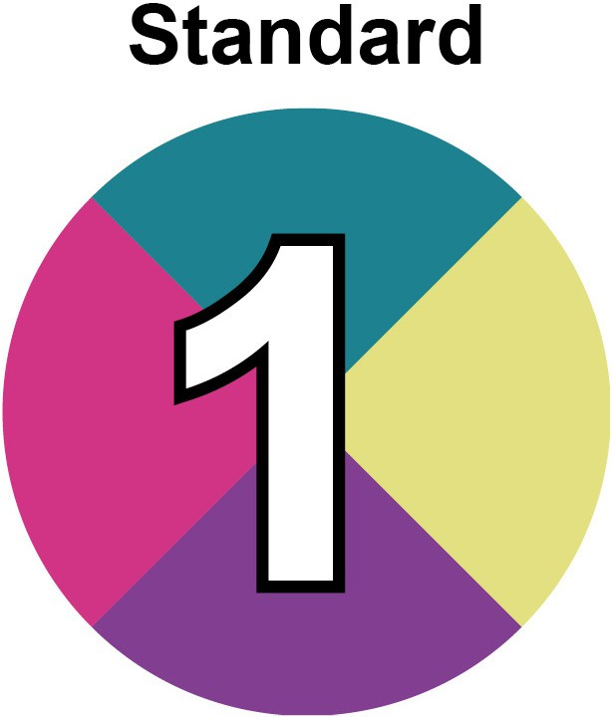
Standard 1 is called Independent support, community brokerage and advocacy.

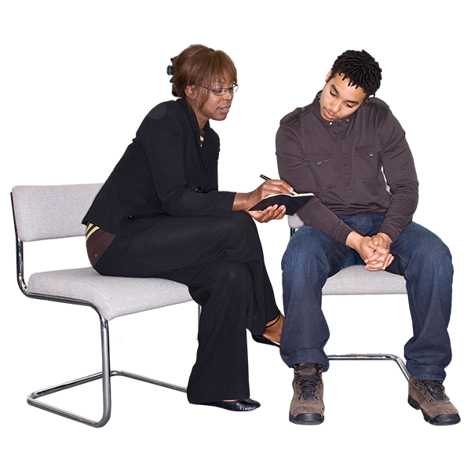
In this document, independent support means organisations helping someone to find out about and get Self-directed Support.


Community brokerage means helping someone to build on their strengths and take part in community life.


Advocacy means having someone speak up for you if you cannot speak up for yourself at that time.

What people should get from Standard 1:

- an offer of independent support
- an offer of community brokerage
- an offer of advocacy
- choice and control of their social care and support
- help to get their human rights


Human rights are the basics rights and freedoms that belong to everyone.


What staff and systems should do for Standard 1 to happen:

- every local council and Health and Social Care Partnership gives information about:

  - independent support
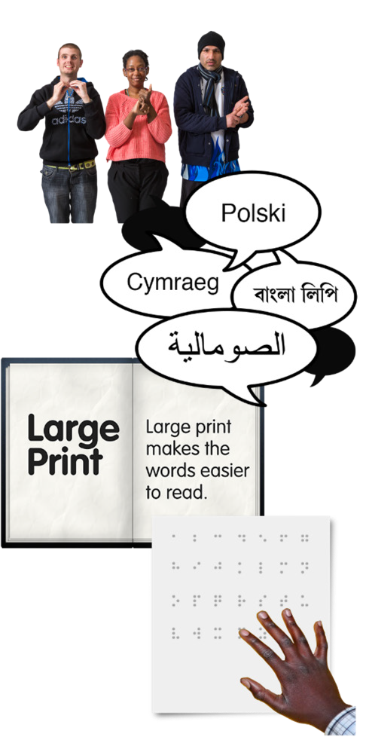
  - community brokerage
  - advocacy

- information is offered in ways that everyone can understand, like:

  - British Sign Language
  - audio
  - a different language
  - large print
  - braille
  - Easy Read

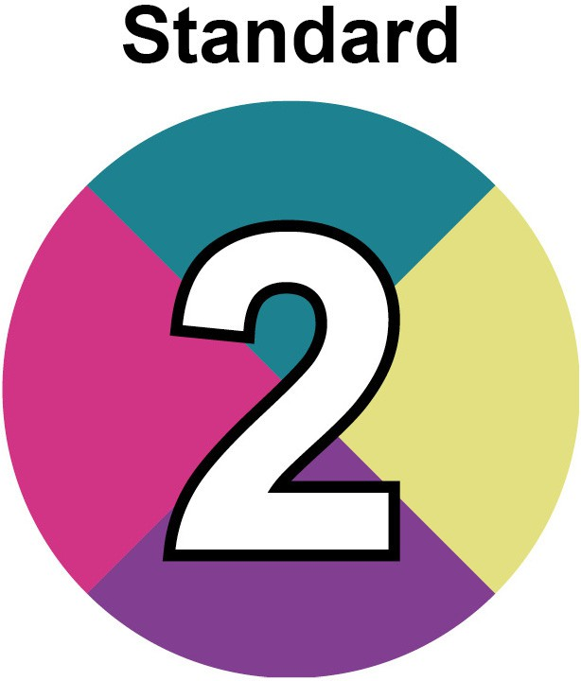
Standard 2 is called Early help, family support and community support.

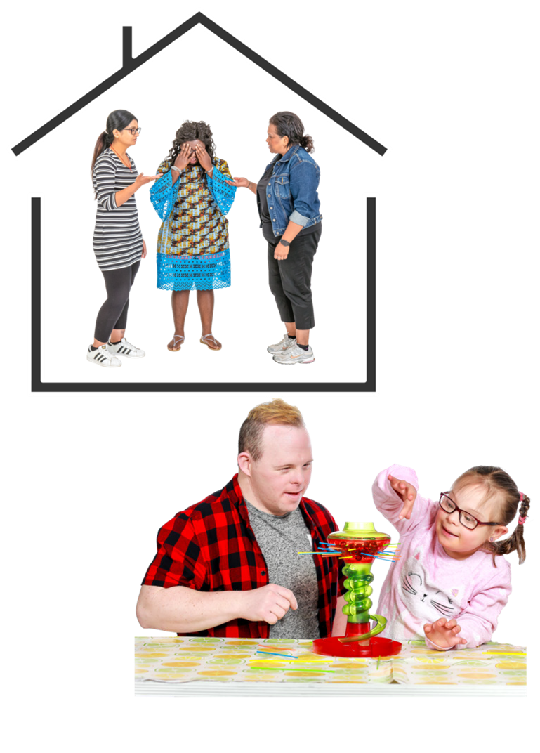
This means things like:

- offering families support as soon as any problems begin

- flexible ways of helping people to live well in their own community


What people should get from Standard 2:

- an offer of early help
- an offer of family support
- an offer of community support for anyone who needs it.


What staff and systems should do for Standard 2 to happen:

- have conversations with people about what is important to them

- work with community groups

- find ways to solve problems and make
wellbeing better


Wellbeing means feeling happy and healthy.

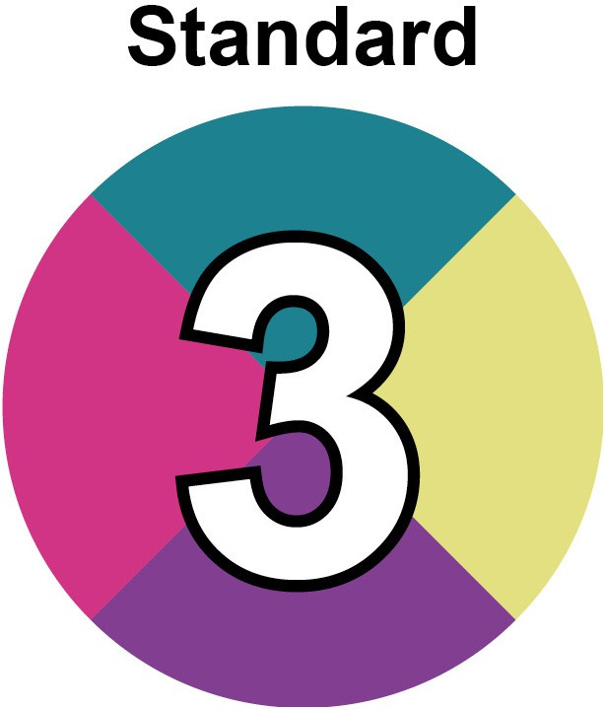
Standard 3 is called Strengths based and asset based assessment, planning and review.


Strengths based assessment means looking for the skills and values that someone has, such as strengths like kindness and curiosity.

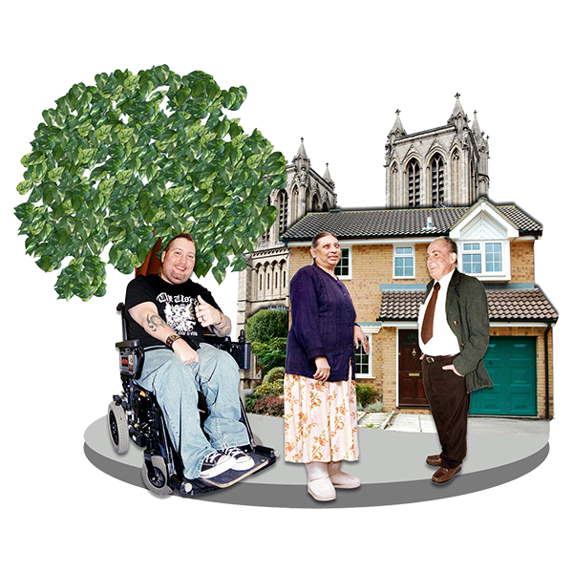
Asset based assessment means looking at someone’s community to see what kinds of things could be helpful to them.


Planning and review means:

- how things are planned

- how they are checked afterwards to see what is working well and what needs to change

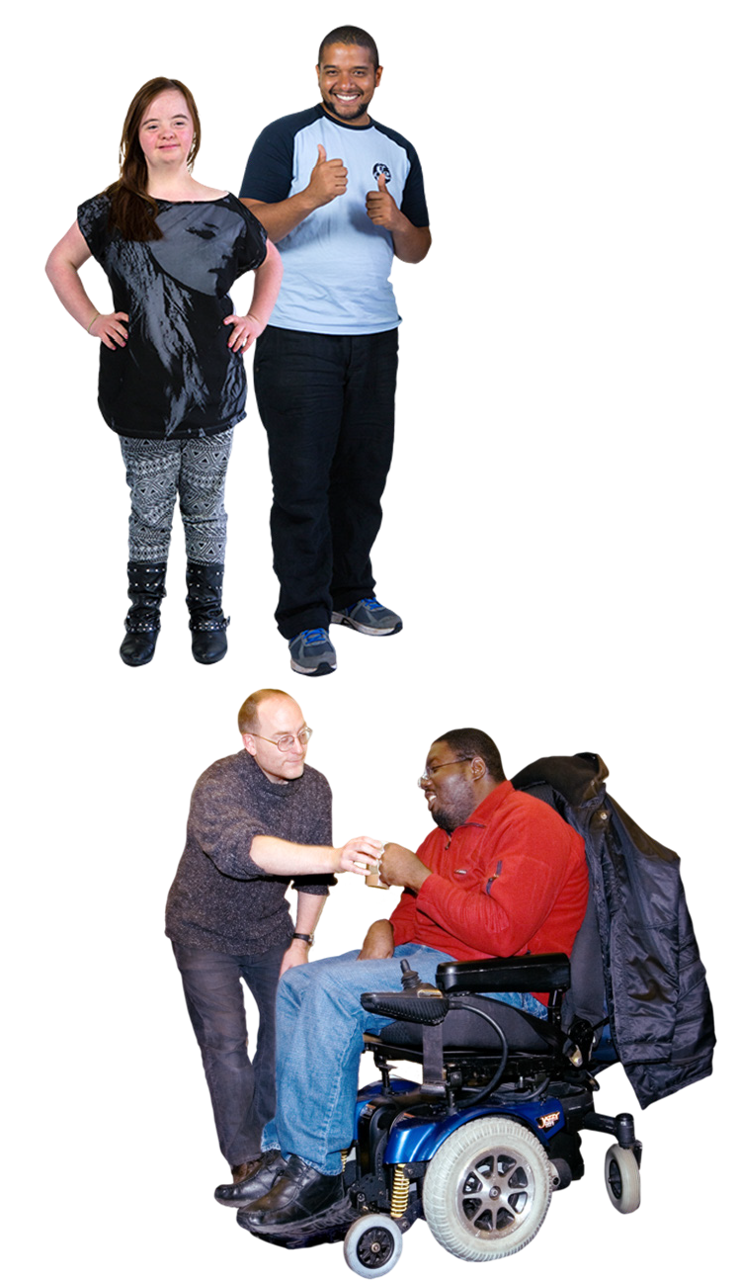
What people should get from Standard 3:

- good conversations with staff

- trusting relationships with staff

- changes and successes in what really matters to each person


What staff and systems should do for Standard 3 to happen:

- have ways of planning and checking that suit each person

- look for people’s strengths and values

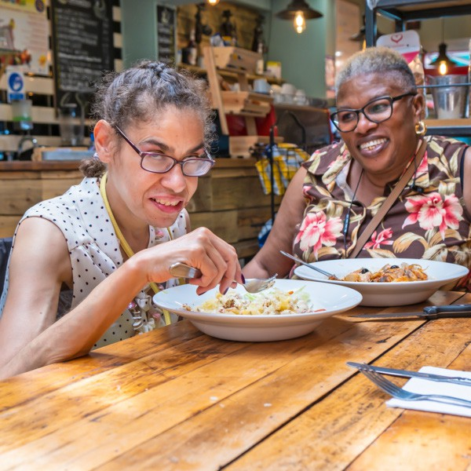
- look for support in a family or community that could be helpful


- make sure that support fits in well with the person’s life

- make aims that support people’s human rights

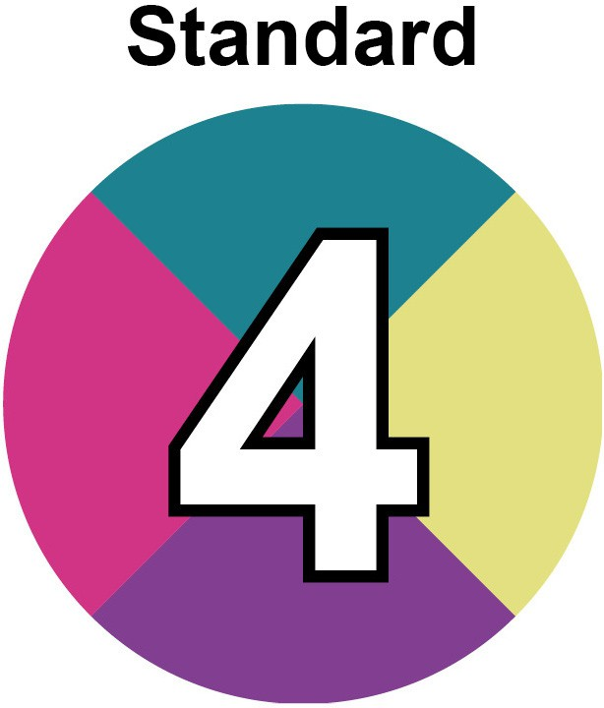
Standard 4 is called Meaningful and measurable recording practices.


Recording practices are the ways that staff might write down or type up what has been done or talked about.

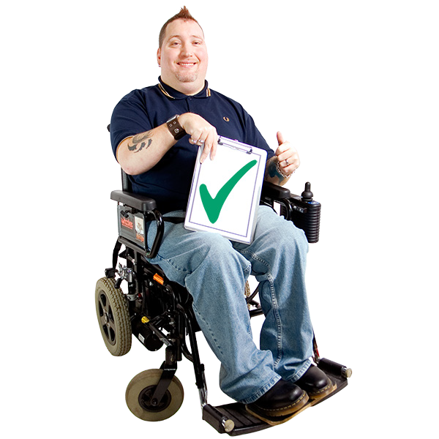
Meaningful means that the notes make sense to the right people and have helpful details.


Measurable means that progress or problems can be seen.


What people should get from Standard 4:

- notes about their conversations and the things that matter to them which are easy to understand


What staff and systems should do for Standard 4 to happen:

- use good ways to record information

- show that Self-directed Support values are in place

- have recording systems that can collect data and use it in other ways to make things better


Data means facts, numbers and information.

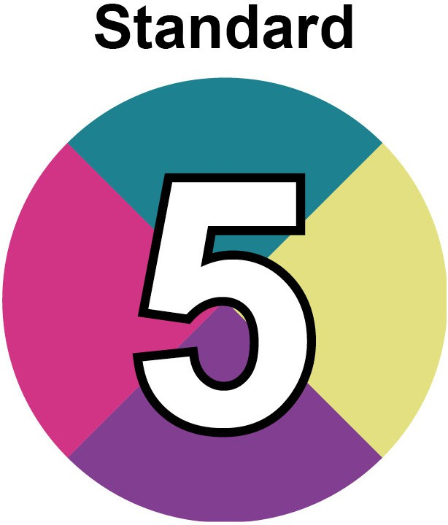
Standard 5 is called Accountability.

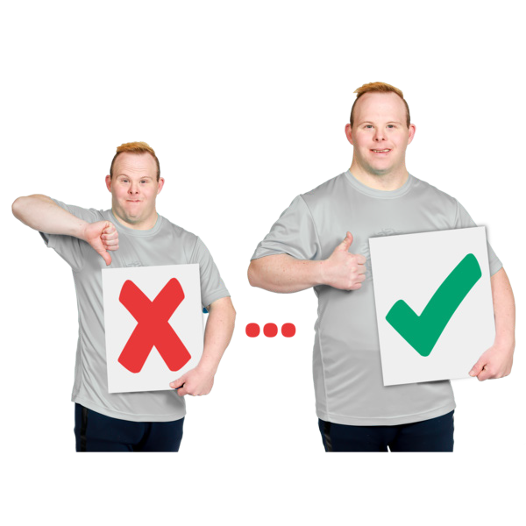
This means things like:

- having trust and respect
- listening to people’s experiences
- making improvements
- supporting human rights
- asking for feedback
- dealing with complaints really well


What people should get from Standard 5:

- their own legal rights

- information they can understand


- advocacy – the offer of someone to speak up for them

- mediation – the offer of an extra person to help sort out a problem

- the chance to say they do not agree with a decision

- the chance to complain if something has gone wrong



What staff and systems should do for Standard 5 to happen:

- have the right rules and systems so that people’s legal rights are in place

- make chances for everyone to have their say

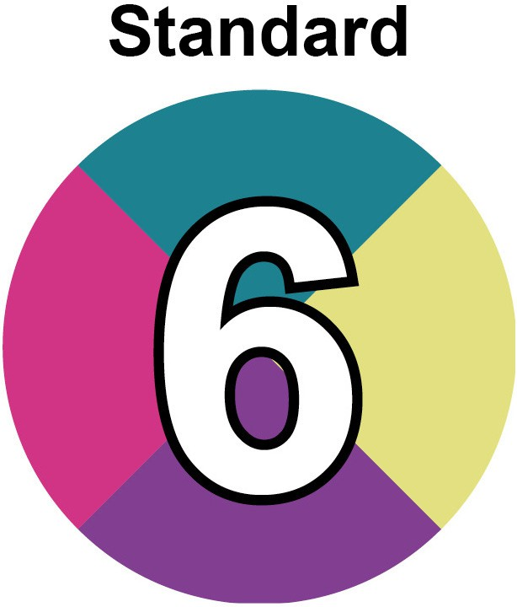

Standard 6 is called Risk enablement.

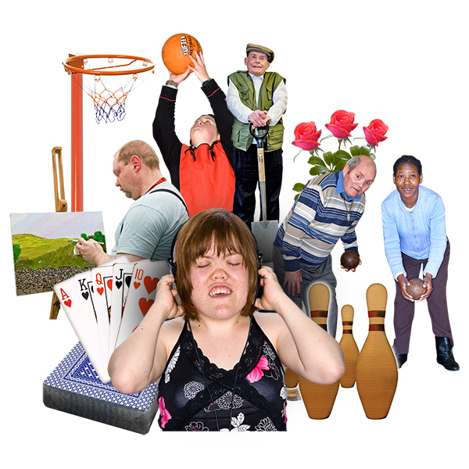
Risk enablement means giving people the freedom to try things that might or might not work. But at the same time keeping them safe.


What people should get from Standard 6:

- feel listened to about how they want to work towards their aims

- advice to help them stay safe while they are choosing their support and taking part in activities

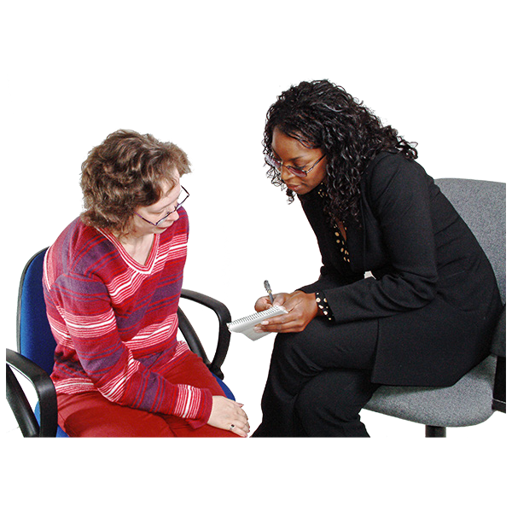
What staff and systems should do for Standard 6 to happen:

- work together with the person who is being supported to plan for a balance between risk and safety

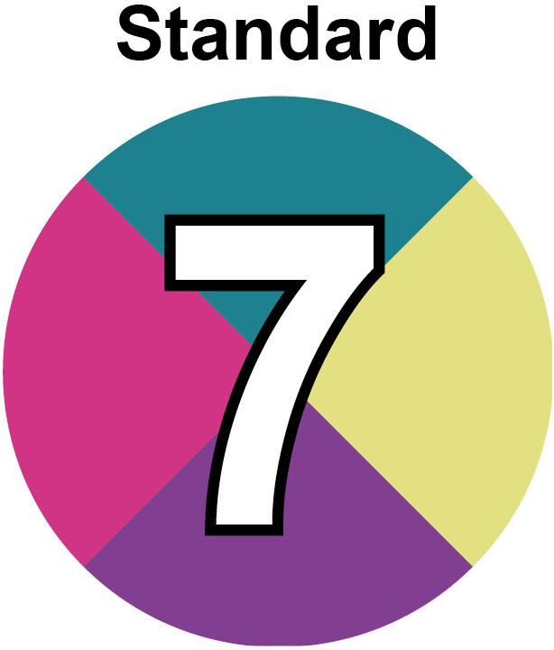
Standard 7 is called Flexible and outcome focused commissioning.


Commissioning means choosing and buying services before they are needed.

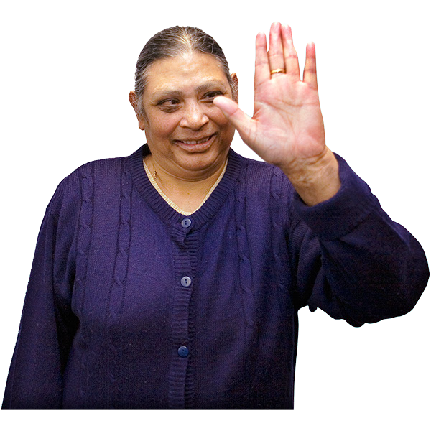
In this document, flexible and outcome focused mean that the services must be about people’s aims and they must be able to change when needed.


What people should get from Standard 7:

- the chance to work together with staff to make services work well

- the chance to plan and check that local services are working well

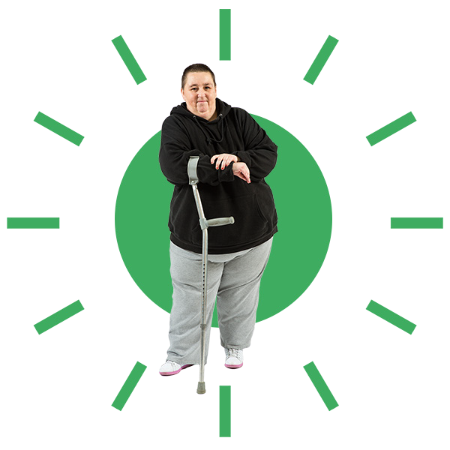
What staff and systems should do for Standard 7 to happen:

- plan social care support and services so that people have choice and flexibility

- start with what matters to people

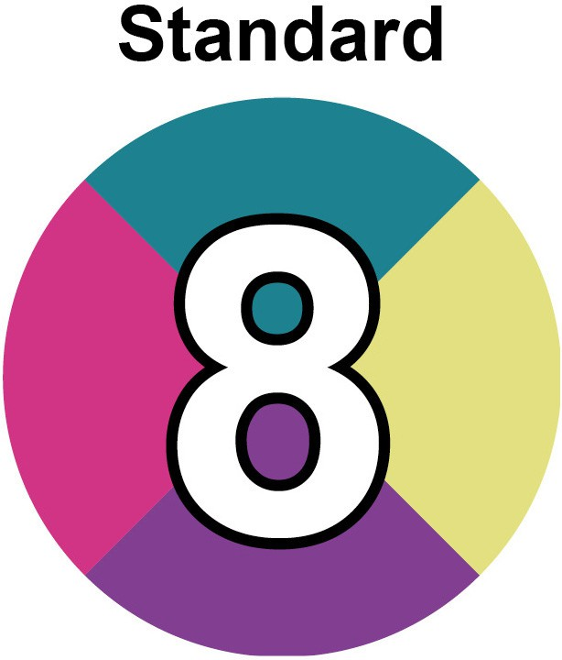
Standard 8 is called Worker autonomy.


In this document worker autonomy means social workers being able to use their judgement, skills and knowledge.

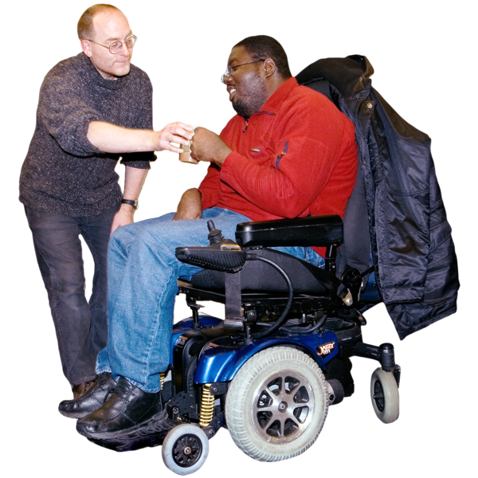
What people should get from Standard 8:

- their social work staff able to make decisions using their own knowledge and skills


What staff and systems should do for Standard 8 to happen:

- trust social workers

- let social workers plan and assess in the right way for people

- let social workers plan for some types of spending

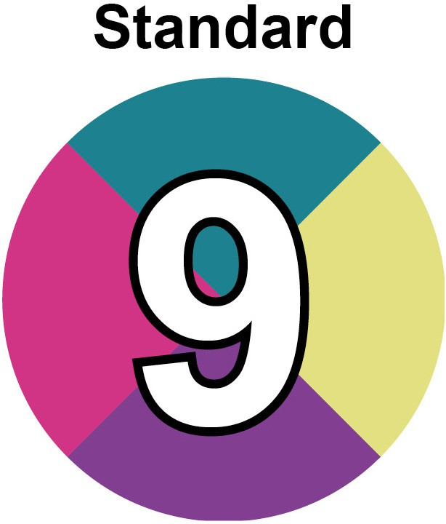
Standard 9 is called Transparency.

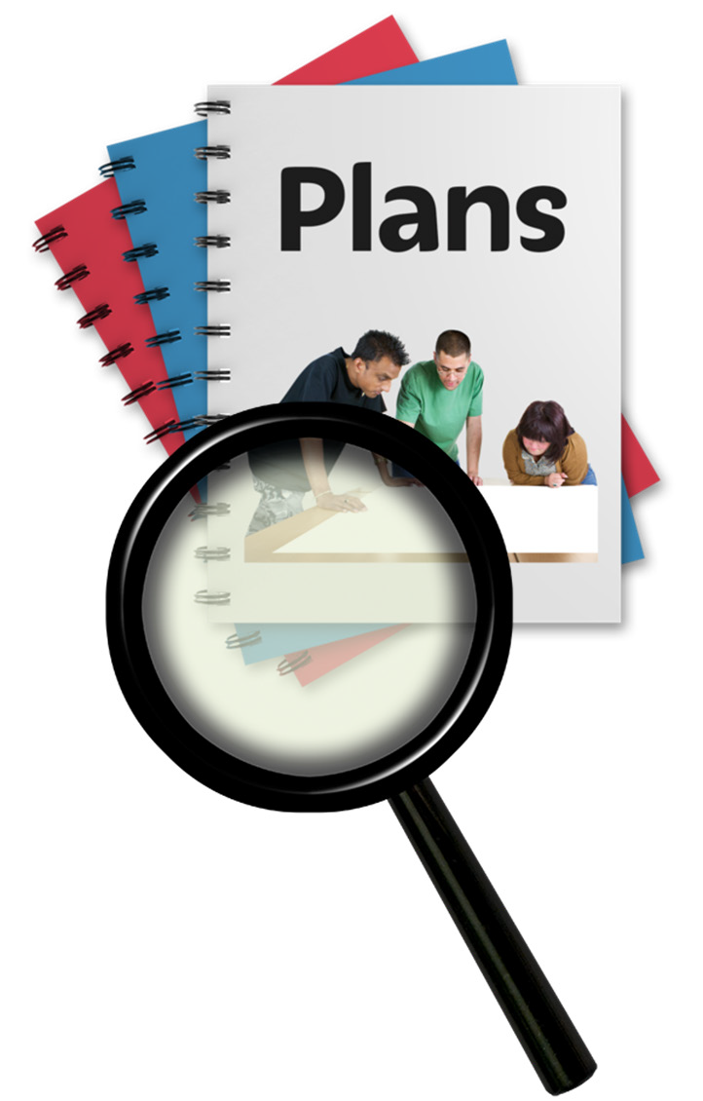
Transparency means being honest and clear about:

- how decisions are made

- how money is spent

- who does what

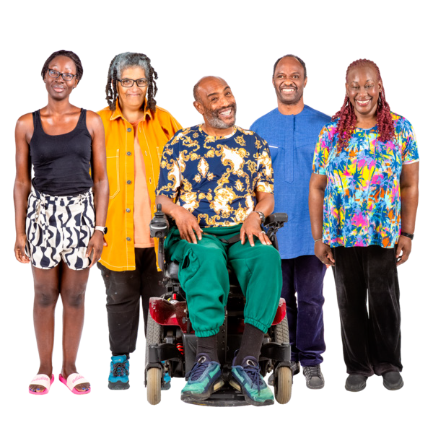
What people should get from Standard 9:

- support from honest and open organisations

- trust and respect

- less problems with organisations

What staff and systems should do for Standard 9 to happen:

- explain things clearly

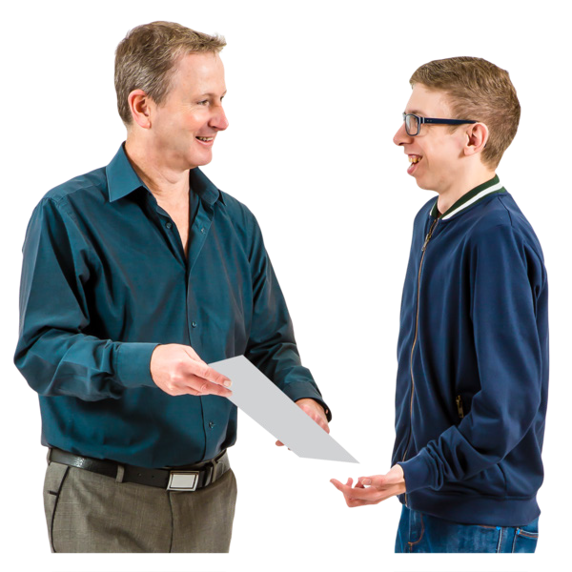
- talk with people about their choices

- talk with people about the different supports they can get

- write down what has been talked about and give a copy to the people being supported

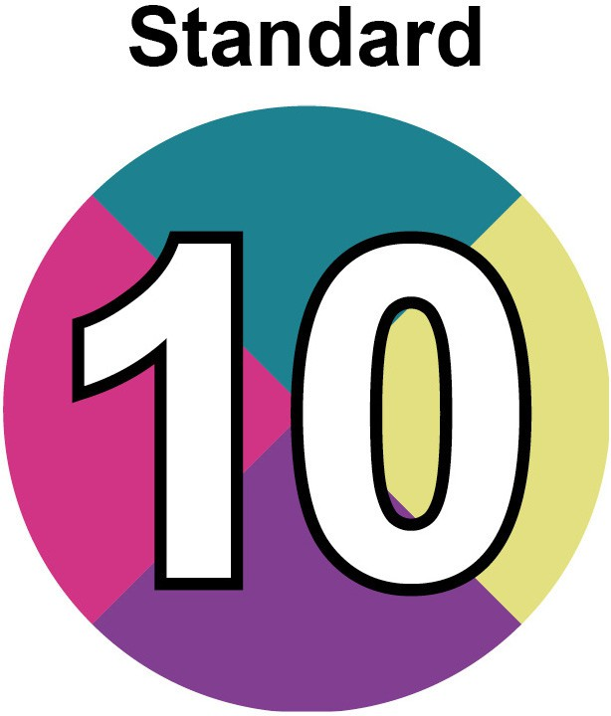
Standard 10 is called Early planning for transitions.


This means planning extra support when these kinds of things are happening in someone’s life:

- moving area
- moving school

- becoming an adult
- starting a job

- having a baby
- going to hospital



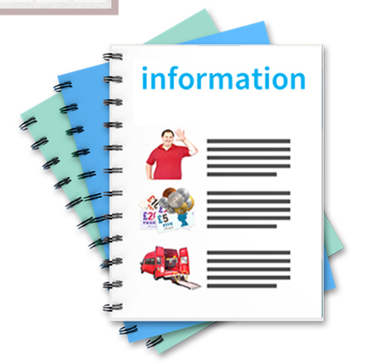
What people should get from Standard 10:

- support for something new happening in their life

- time to get ready

- information about the change

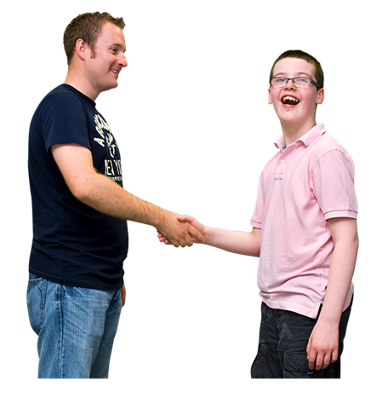
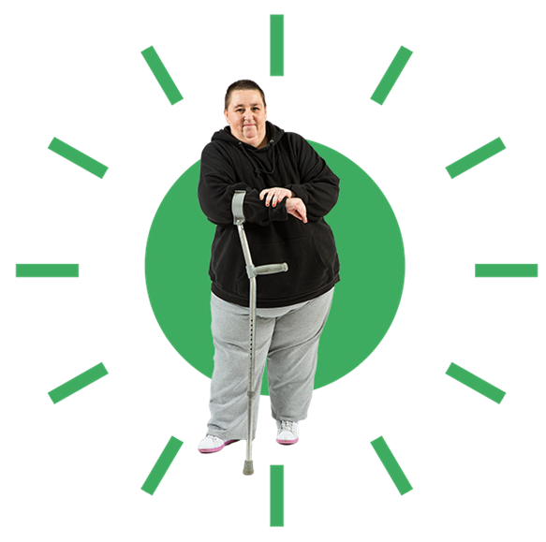
What staff and systems should do for Standard 10 to happen:

- support people to plan early

- make sure that wellbeing and the person’s hopes are the most important parts of their plans

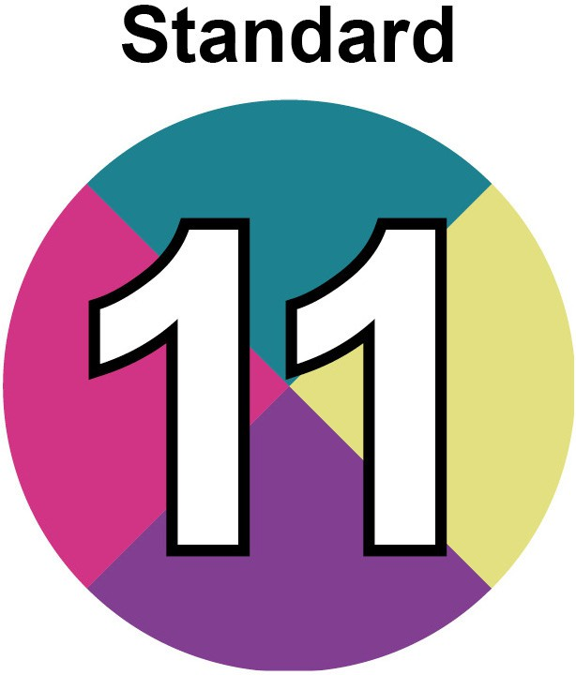
Standard 11 is called Consistency of practice.

This means that wherever in Scotland someone lives, they get good support.

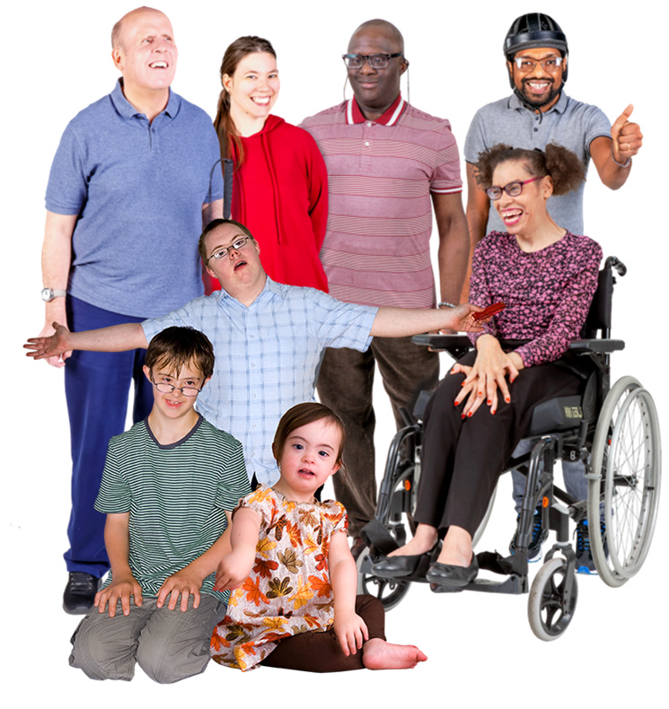
What people should get from Standard 11:

- good support wherever they live

- good support whatever their age or stage in life

- good support whatever their lifestyle is like

What staff and systems should do for Standard 11 to happen:

- do high quality work for:
  - assessments
  - early help

  - planning
  - checking
  - supporting

- check that people in different parts of Scotland are getting high quality support

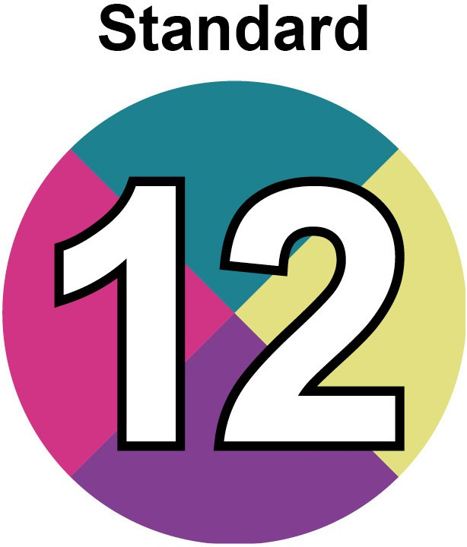
Standard 12 is called Access to budgets and flexibility of spend.


This means how money is spent to support someone.


What people should get from Standard 12:

- choice in how their support money is spent

- the chance to change how it is spent

- a fair share of funding

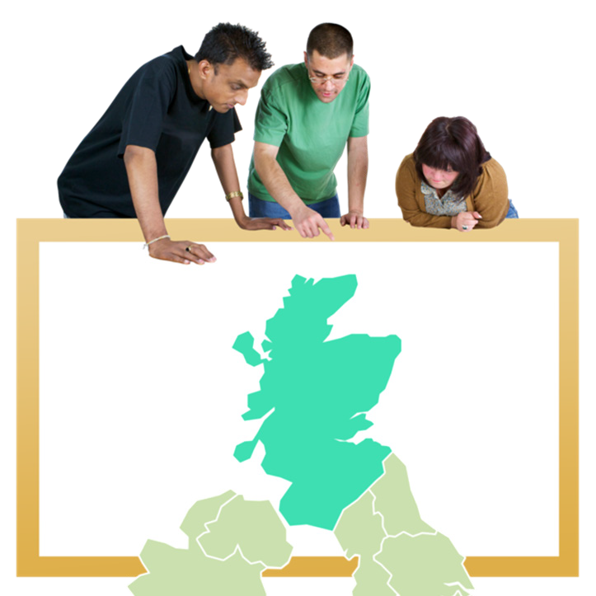
What staff and systems should do for Standard 12 to happen:

- organisations like local councils need to have clear and fair systems

- share funding around Scotland fairly

- make it easy for people to take part in deciding how their funding should be spent


- put clear rules in place so that people understand where and how they can spend their funding

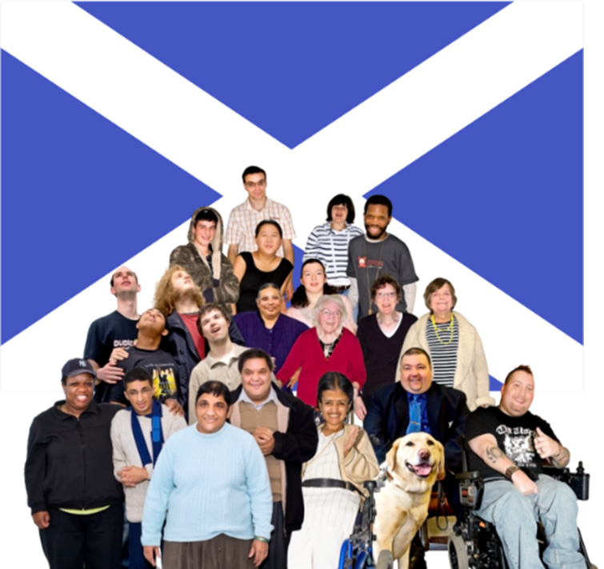
Who the Framework is for

The Framework is for all people and organisations.

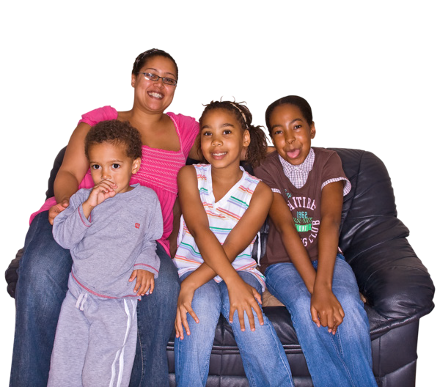
It is for:

- children and young people
- supported people and families
- carers

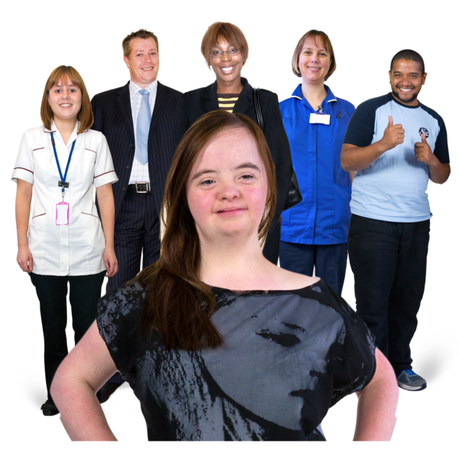
It is for:

- local councils
- Health and Social Care Partnerships
- NHS organisations
- Integration Joint Board staff


It is also for everyone who works for Self- directed Support, like:

- social work staff
- finance staff
- unpaid carers
- Personal Assistants
- people who access social work and social care
- people who provide services
- disabled people’s organisations
- independent support organisations

More information


If you want to know more about the Framework you can email us at sds.team@socialworkscotland.org

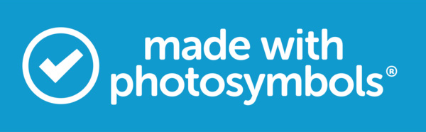



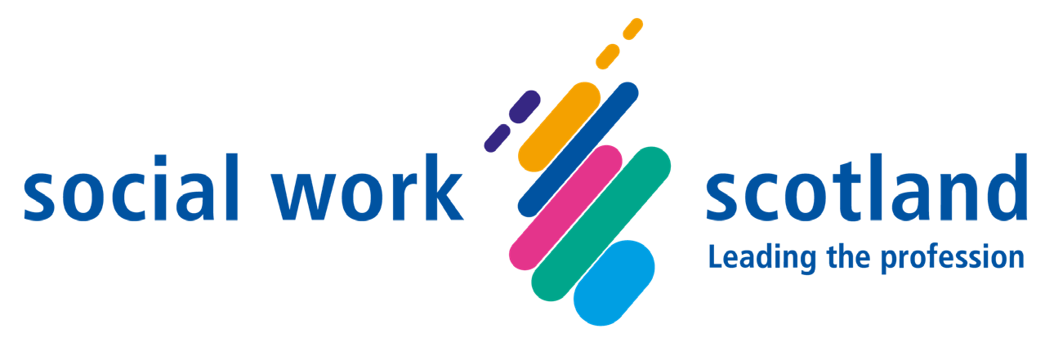

Self-directed Support Team
Social Work Scotland May 2024
socialworkscotland.org sds.team@socialworkscotland.org

